Digital Nurture 4.0 – Week 6
React

(a) Mandatory hands-on
Filename : 9. ReactJS-HOL
Step 1:
Install node.js from official website and setup on the system.And Create a new folder named react9 for this project and open on vs code.

Step 2:
Run the command npx create-react-app cricketapp on the vs code terminal.And redirect to the react folder named cricketapp.Create ListofPlayers.js and IndianPlayers.js in the src/components directory.Change the App.js code in the src/App.js directory.

ListofPlayers.js:
import React from 'react';
const ListofPlayers = () => {
const players = [
{ name: "Mr. Jack", score: 50 },
{ name: "Mr. Michael", score: 70 },
{ name: "Mr. John", score: 40 },
{ name: "Mr. Ann", score: 61 },
{ name: "Mr. Elisabeth", score: 61 },
{ name: "Mr. Sachin", score: 95 },
{ name: "Mr. Dhoni", score: 100 },
{ name: "Mr. Virat", score: 84 },
{ name: "Mr. Jadeja", score: 64 },
{ name: "Mr. Raina", score: 75 },
{ name: "Mr. Rohit", score: 80 }
];

const lowScorePlayers = players.filter(p => p.score < 70);

return (
<div>
<h2>List of Players</h2>
<ul>
{players.map((player, idx) => (
<li key={idx}>{player.name} {player.score}</li>
))}
</ul>

<h2>List of Players having Scores Less than 70</h2>
<ul>
{lowScorePlayers.map((player, idx) => (
<li key={idx}>{player.name} {player.score}</li>
))}
</ul>
</div>
);
};
export default ListofPlayers;

IndianPlayers.js:
import React from 'react';

const IndianPlayers = () => {
const players = ["Sachin1", "Dhoni2", "Virat3", "Rohit4", "Yuvaraj5", "Raina6"];
const oddPlayers = players.filter((_, idx) => idx % 2 === 0);
const evenPlayers = players.filter((_, idx) => idx % 2 !== 0);

const t20 = ["Mr. First Player", "Mr. Second Player", "Mr. Third Player"];
const ranji = ["Mr. Fourth Player", "Mr. Fifth Player", "Mr. Sixth Player"];
const mergedPlayers = [...t20, ...ranji];

return (
<div>
<h2>Odd Players</h2>
<ul>
{oddPlayers.map((player, idx) => (
<li key={idx}>{["First", "Third", "Fifth"][idx]} : {player}</li>
))}
</ul>

<h2>Even Players</h2>
<ul>
{evenPlayers.map((player, idx) => (
<li key={idx}>{["Second", "Fourth", "Sixth"][idx]} : {player}</li>
))}
</ul>

<h2>List of Indian Players Merged:</h2>
<ul>
{mergedPlayers.map((player, idx) => (
<li key={idx}>{player}</li>
))}
</ul>
</div>
);
};
export default IndianPlayers;

App.js:
import React from 'react';
import ListofPlayers from './components/ListofPlayers';
import IndianPlayers from './components/IndianPlayers';
function App() {
const flag = true;

return (
<div>
{flag ? <ListofPlayers /> : <IndianPlayers />}
</div>
);
}
export default App;

Step 3:
Run the command npm start on your vs code terminal.
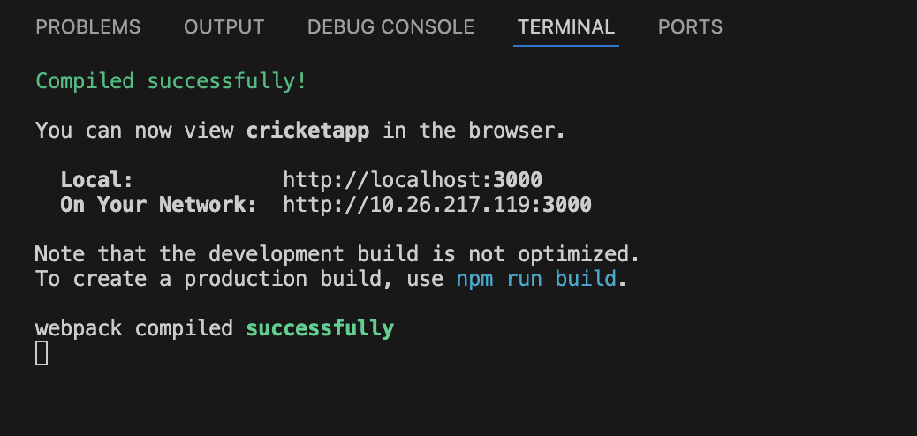

It opens on browser when flag=true in App.js.
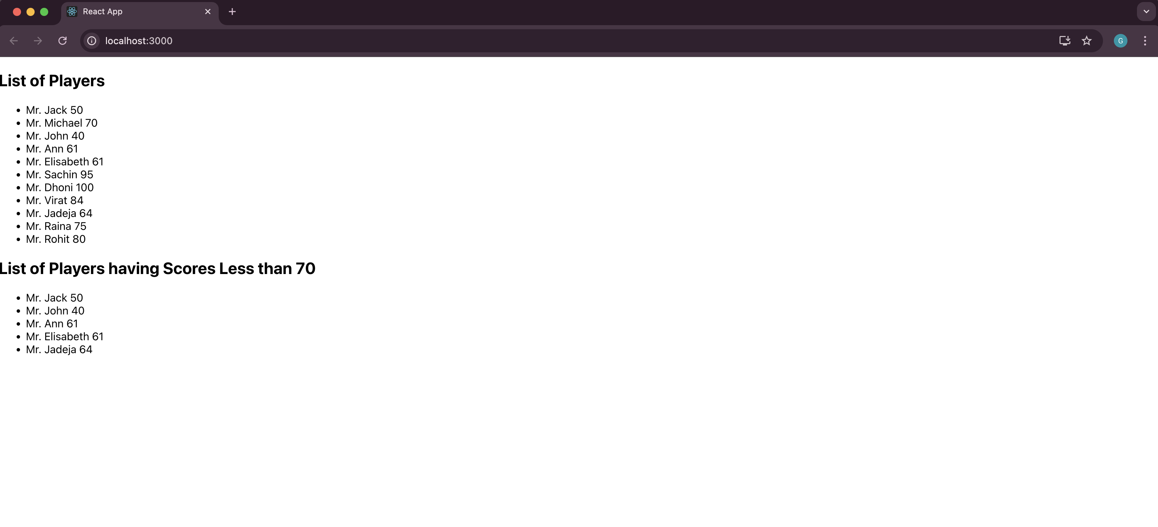
After change flag=false.
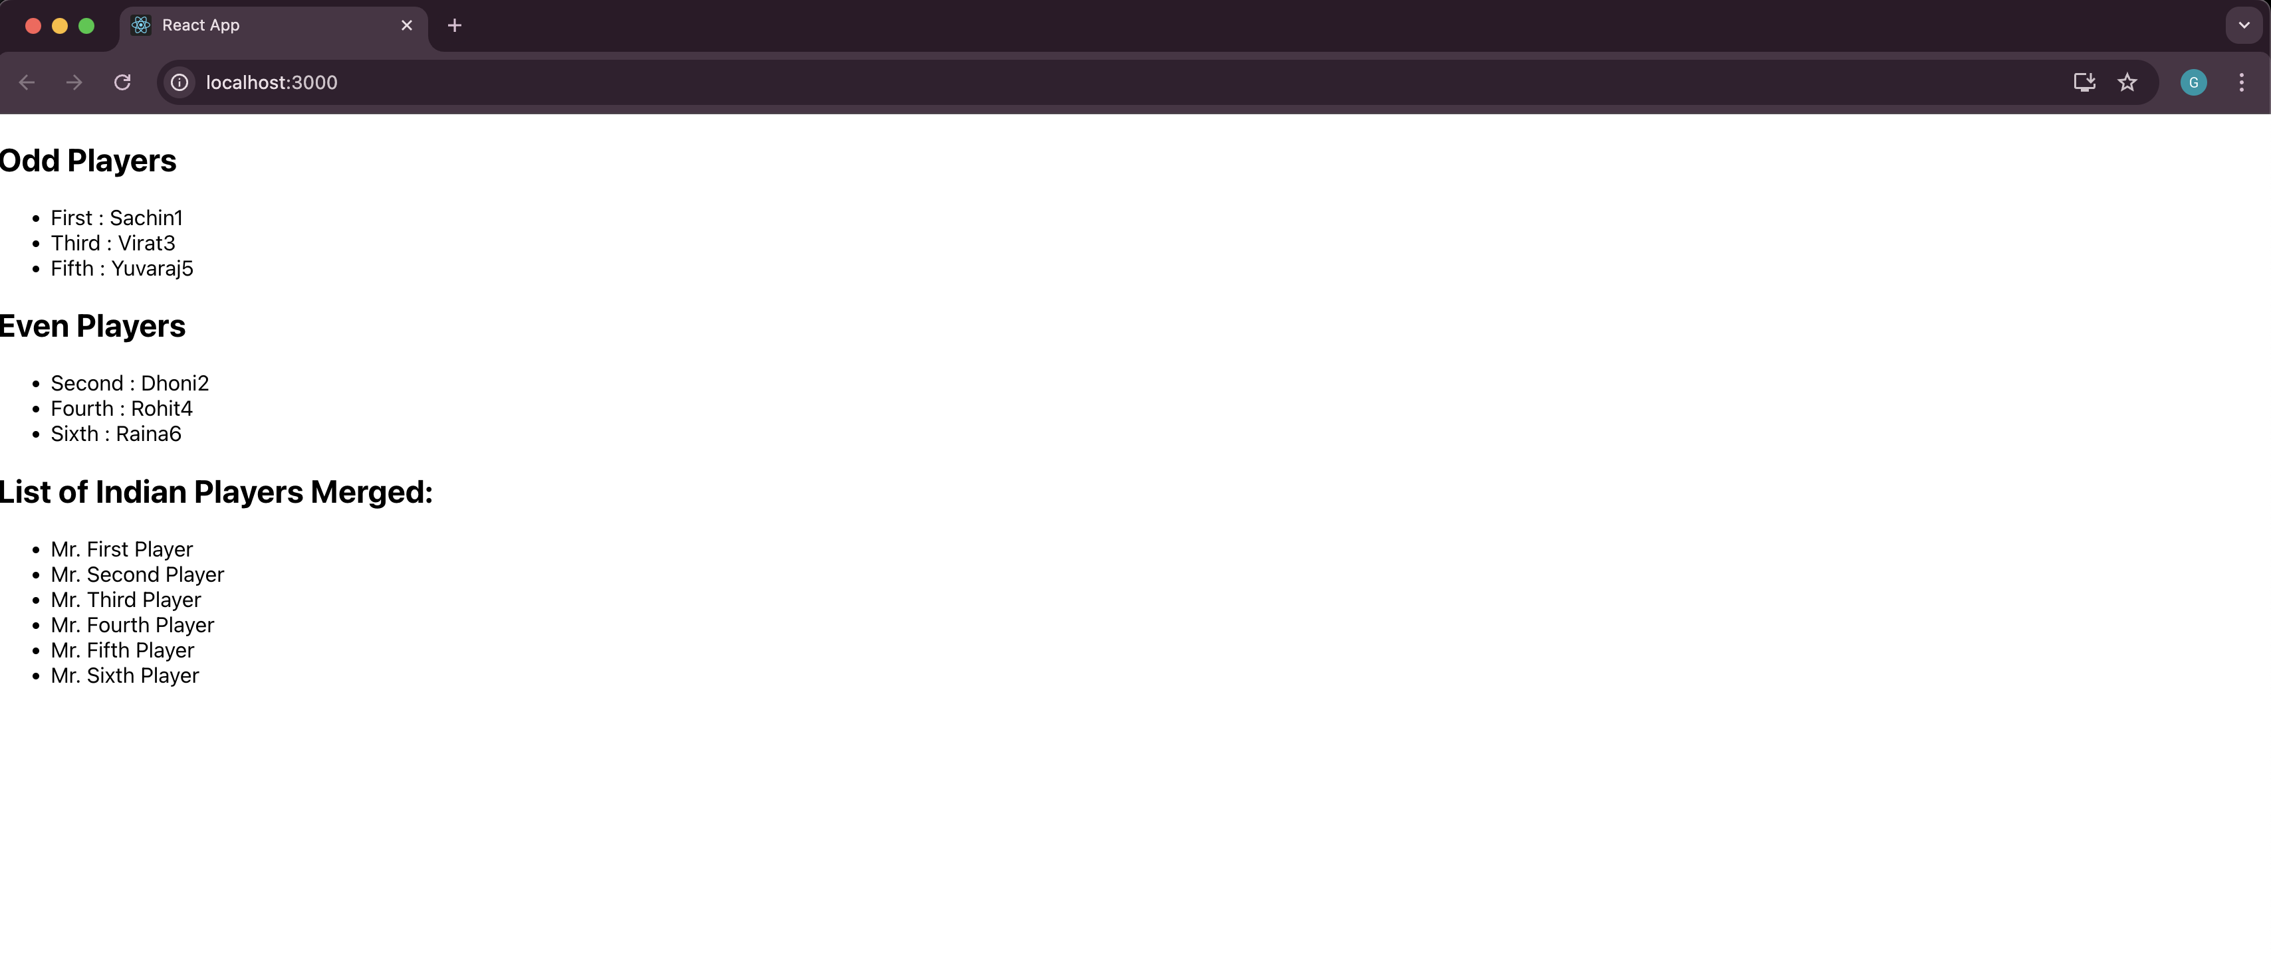
Filename : 10. ReactJS-HOL
Step 1:
Install node.js from official website and setup on the system.And Create a new folder named react10 for this project and open on vs code.

Step 2:
Run the command npx create-react-app officespacerentalapp on the vs code terminal.And redirect to the react folder named officespacerentalapp.Change the App.js and App.css code in the src/ directory.And save office.jpg file in the src/assets/ directory.

App.js:
import React from 'react';
import './App.css';
import officeImg from './assets/office.jpg';

function App() {
const element = "Office Space";
const jsxatt = <img src={officeImg} width="25%" height="25%" alt="Office Space" />;
const ItemName = { Name: "DBS", Rent: 50000, Address: "Chennai" };

let colors = [];
if (ItemName.Rent <= 60000) {
colors.push('textRed');
} else {
colors.push('textGreen');
}

return (
<div className="App">
<h1>{element} , at Affordable Range </h1>
{jsxatt}
<h1>Name: {ItemName.Name}</h1>
<h3 className={colors.join(' ')}>Rent: Rs. {ItemName.Rent}</h3>
<h3>Address: {ItemName.Address}</h3>
</div>
);
}
export default App;

App.css:
.App {
text-align: center;
font-family: Arial, sans-serif;
padding: 30px;
}

.textRed {
color: red;
font-weight: bold;
}

.textGreen {
color: green;
font-weight: bold;
}

Office.jpg:


Step 3:
Run the command npm start on your vs code terminal.
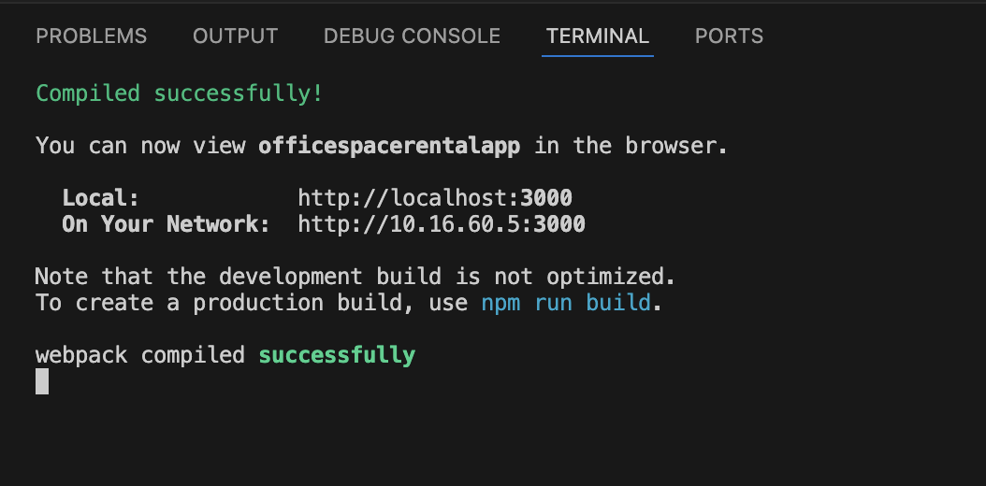
It opens the browser.
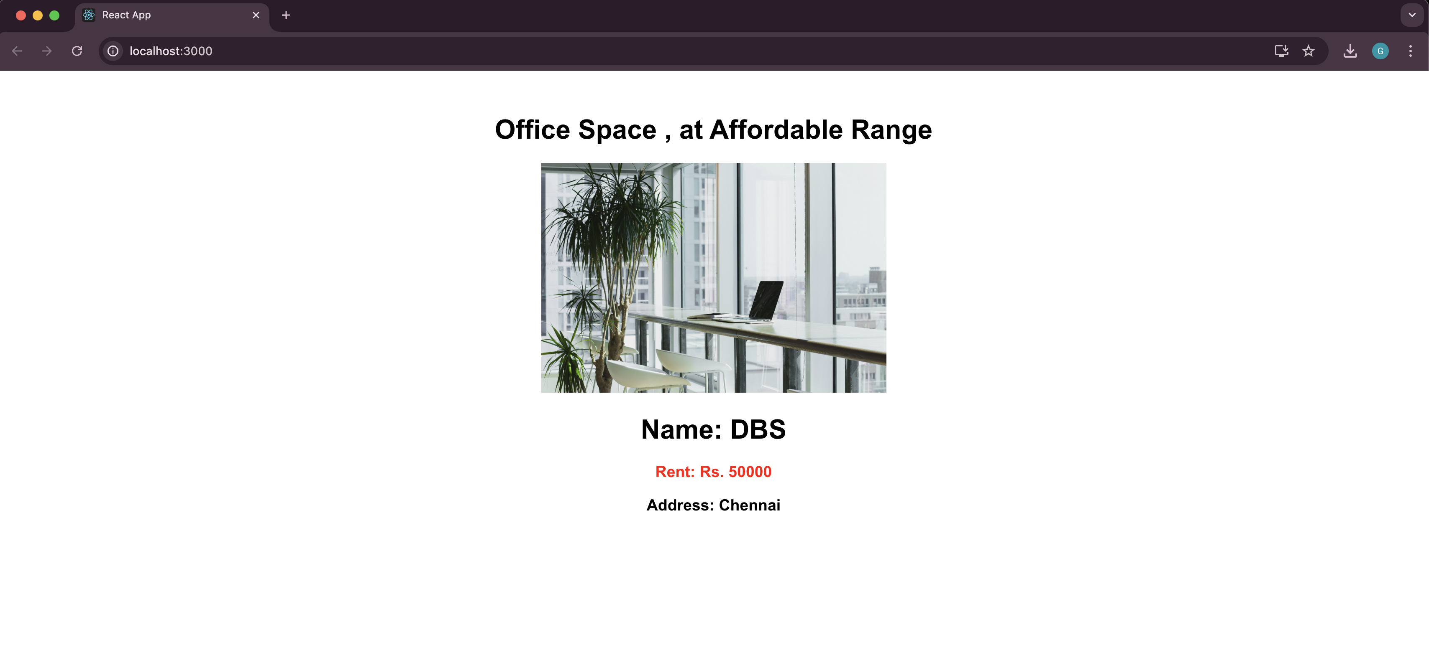

Filename : 11. ReactJS-HOL
Step 1:
Install node.js from official website and setup on the system.And Create a new folder named react11 for this project and open on vs code.

Step 2:
Run the command npx create-react-app officespacerentalapp on the vs code terminal.And redirect to the react folder named officespacerentalapp.Change the App.js and App.css code in the src/ directory.And Create CurrencyConvertor.js and CurrencyConvertor.css in the src/ directory.

CurrencyConvertor.js:
import React, { Component } from 'react';
import './CurrencyConvertor.css';

class CurrencyConvertor extends Component {
constructor(props) {
super(props);
this.state = {
amount: '',
currency: ''
};
this.handleChange = this.handleChange.bind(this);
this.handleCurrencyChange = this.handleCurrencyChange.bind(this);
this.handleSubmit = this.handleSubmit.bind(this);
}

handleChange(e) {
this.setState({ amount: e.target.value });
}

handleCurrencyChange(e) {
this.setState({ currency: e.target.value });
}

handleSubmit(e) {
e.preventDefault();
const convertedAmount = this.state.amount * 80;
alert(`Converting to ${this.state.currency} Amount is ${convertedAmount}`);
}

render() {
return (
<div className="currency-section">
<h2 className="title">Currency Convertor!!!</h2>
<form onSubmit={this.handleSubmit}>
<label>Amount: </label>
<input
type="text"
value={this.state.amount}
onChange={this.handleChange}
/><br /><br />
<label>Currency: </label>
<textarea
value={this.state.currency}
onChange={this.handleCurrencyChange}
/><br /><br />
<button type="submit">Submit</button>
</form>
</div>
);
}
}
export default CurrencyConvertor;

CurrencyConvertor.css:
.currency-section {
margin-top: 30px;
}

.title {
color: green;
font-size: 28px;
font-weight: bold;
}

App.js:
import React, { Component } from 'react';
import './App.css';
import CurrencyConvertor from './CurrencyConvertor';

class App extends Component {
constructor(props) {
super(props);
this.state = {
count: 0
};
this.increment = this.increment.bind(this);
this.sayHello = this.sayHello.bind(this);
this.handleIncrement = this.handleIncrement.bind(this);
this.sayWelcome = this.sayWelcome.bind(this);
this.handleClick = this.handleClick.bind(this);
}

increment() {
this.setState({ count: this.state.count + 1 });
}

decrement = () => {
this.setState({ count: this.state.count - 1 });
};

sayHello() {
alert("Hello! Member1");
}

handleIncrement() {
this.increment();
this.sayHello();
}

sayWelcome(message) {
alert(message);
}

handleClick(e) {
alert("i was clicked");
}

render() {
return (
<div className="App">
<h4>{this.state.count}</h4>
<button onClick={this.handleIncrement}>Increment</button><br />
<button onClick={this.decrement}>Decrement</button><br />
<button onClick={() => this.sayWelcome("welcome")}>Say welcome</button><br />
<button onClick={this.handleClick}>Click on me</button><br /><br />

<CurrencyConvertor />
</div>
);
}
}
export default App;

App.css:
.App {
font-family: Arial, sans-serif;
padding: 20px;
}
button {
margin: 5px 0;
padding: 5px 10px;
}

Step 3:
Run the command npm start on your vs code terminal.
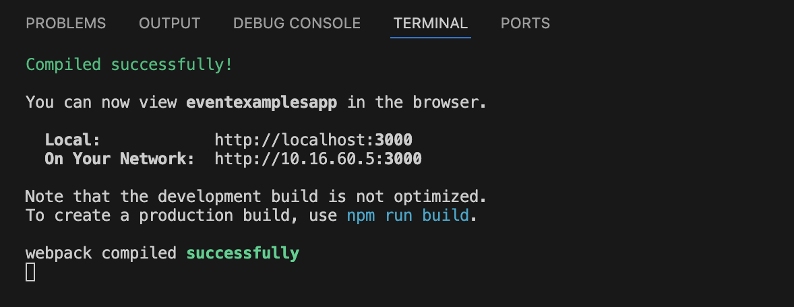
It opens the browser.
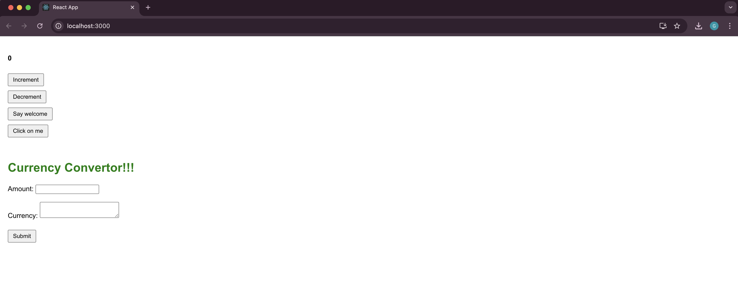

Filename : 12. ReactJS-HOL
Step 1:
Install node.js from official website and setup on the system.And Create a new folder named react12 for this project and open on vs code.

Step 2:
Run the command npx create-react-app ticketbookingapp on the vs code terminal.And redirect to the react folder named ticketbookingapp.Change the App.js code in the src/App.js directory.

App.js:
import React, { useState } from 'react';

function LoginButton(props) {
return (
<button onClick={props.onClick}>
Login
</button>
);
}

function LogoutButton(props) {
return (
<button onClick={props.onClick}>
Logout
</button>
);
}

function UserGreeting() {
return <h1>Welcome back.</h1>;
}

function GuestGreeting() {
return <h1>Please sign up.</h1>;
}

function Greeting(props) {
const isLoggedIn = props.isLoggedIn;
if (isLoggedIn) {
return <UserGreeting />;
}
return <GuestGreeting />;
}

function App() {
const [isLoggedIn, setIsLoggedIn] = useState(false);

let button;
if (isLoggedIn) {
button = <LogoutButton onClick={() => setIsLoggedIn(false)} />;
} else {
button = <LoginButton onClick={() => setIsLoggedIn(true)} />;
}

return (
<div style={{ textAlign: 'center', marginTop: '100px' }}>
<Greeting isLoggedIn={isLoggedIn} />
{button}
</div>
);
}
export default App;

Step 3:
Run the command npm start on your vs code terminal.
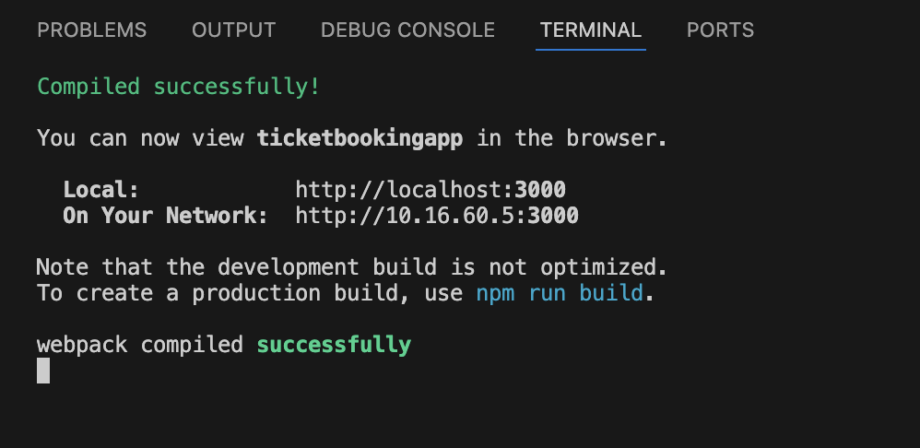
It opens the browser and shows below content on the webpage.
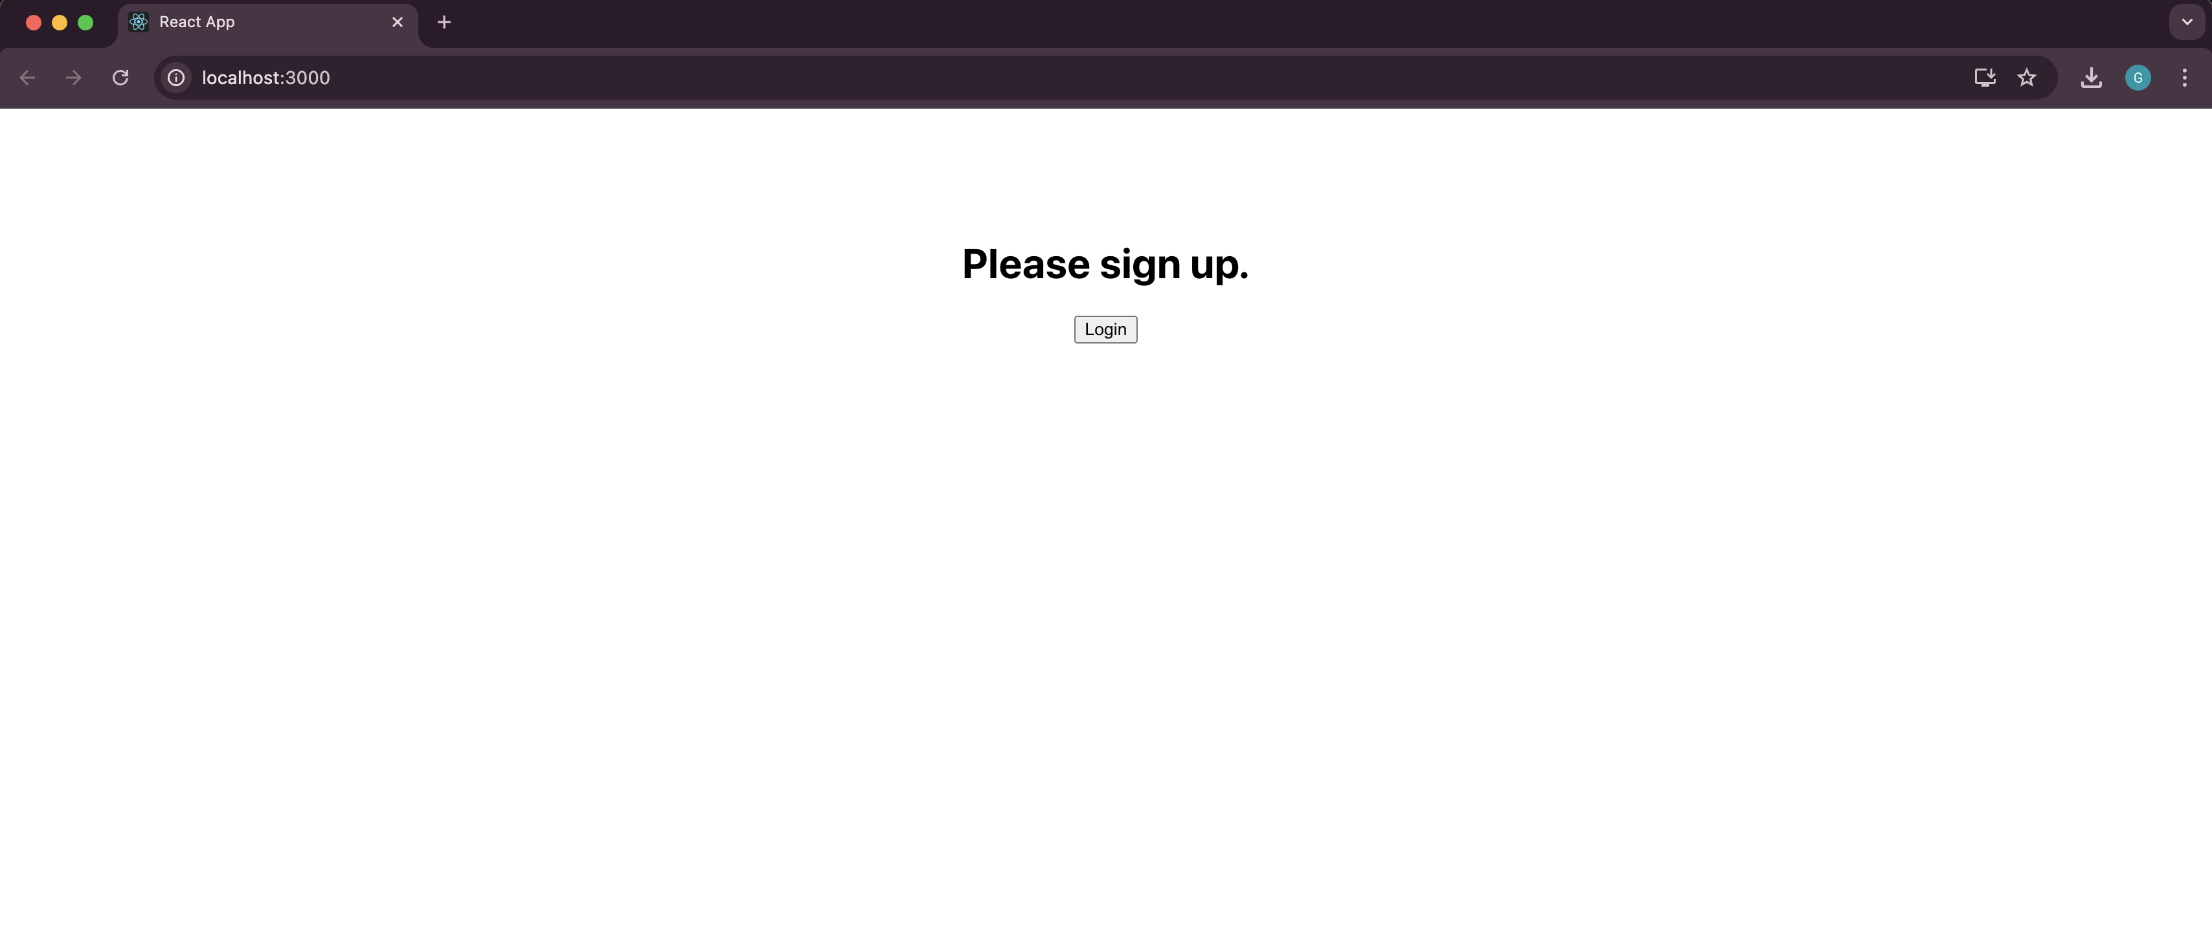
If I click login it shows below content on the new webpage.
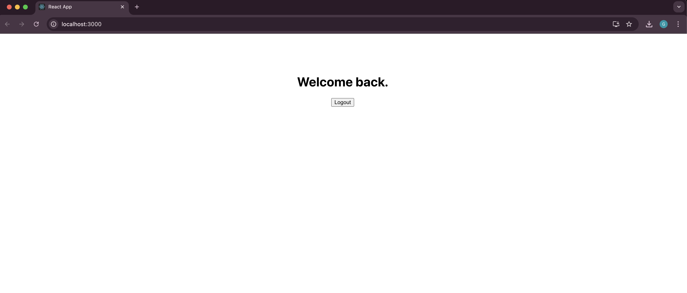
Filename : 13. ReactJS-HOL
Step 1:
Install node.js from official website and setup on the system.And Create a new folder named react13 for this project and open on vs code.

Step 2:
Run the command npx create-react-app bloggerapp on the vs code terminal.And redirect to the react folder named bloggerapp.Change the App.js and App.css code in the src/ directory.

App.js:
import React from 'react';
import './App.css';

function App() {
return (
<div className="container">

<div className="section">
<h1>Course Details</h1>
<div className="content">
<h2>Angular</h2>
<h3>4/5/2021</h3>
<h2>React</h2>
<h3>6/3/20201</h3>
</div>
</div>

<div className="section middle">
<h1>Book Details</h1>
<div className="content">
<h2>Master React</h2>
<h3>670</h3>
<h2>Deep Dive into Angular 11</h2>
<h3>800</h3>
<h2>Mongo Essentials</h2>
<h3>450</h3>
</div>
</div>

<div className="section">
<h1>Blog Details</h1>
<div className="content">
<h2>React Learning</h2>
<h3>Stephen Biz</h3>
<p>Welcome to learning React!</p>
<h2>Installation</h2>
<h3>Schwezdenier</h3>
<p>You can install React from npm.</p>
</div>
</div>

</div>
);
}

export default App;

App.css:
.container {
display: flex;
justify-content: center;
align-items: center;
height: 100vh;
gap: 40px;
font-family: Arial, sans-serif;
}

.section {
width: 250px;
text-align: left;
}

.middle {
border-left: 4px solid green;
border-right: 4px solid green;
padding: 0 20px;
}

h1 {
font-size: 22px;
margin: 0 0 32px 0;
}

.content {
padding-left: 32px;
}

h2 {
font-size: 18px;
font-weight: bold;
margin: 10px 0 4px 0;
}

h3, h4 {
margin: 5px 0;
}

p {
margin: 5px 0;
}

ul {
list-style: none;
padding-left: 0;
margin: 0;
}
Step 3:
Run the command npm start on your vs code terminal.
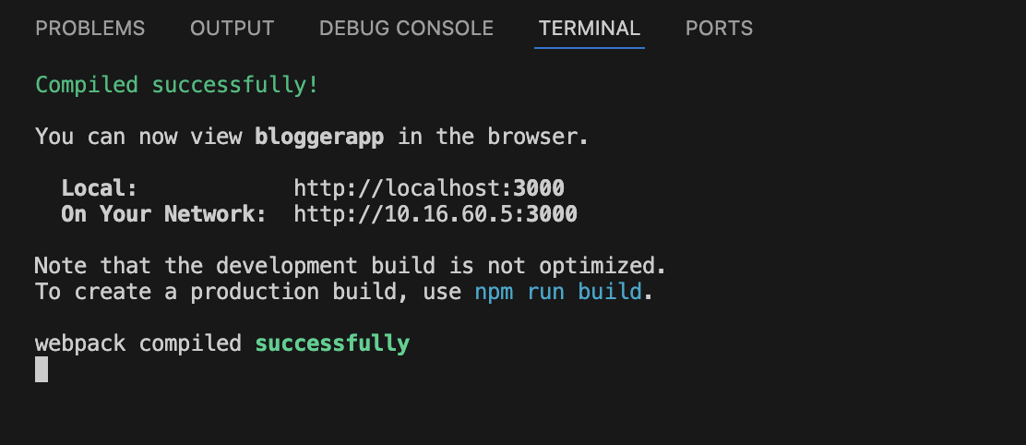

It opens the browser.
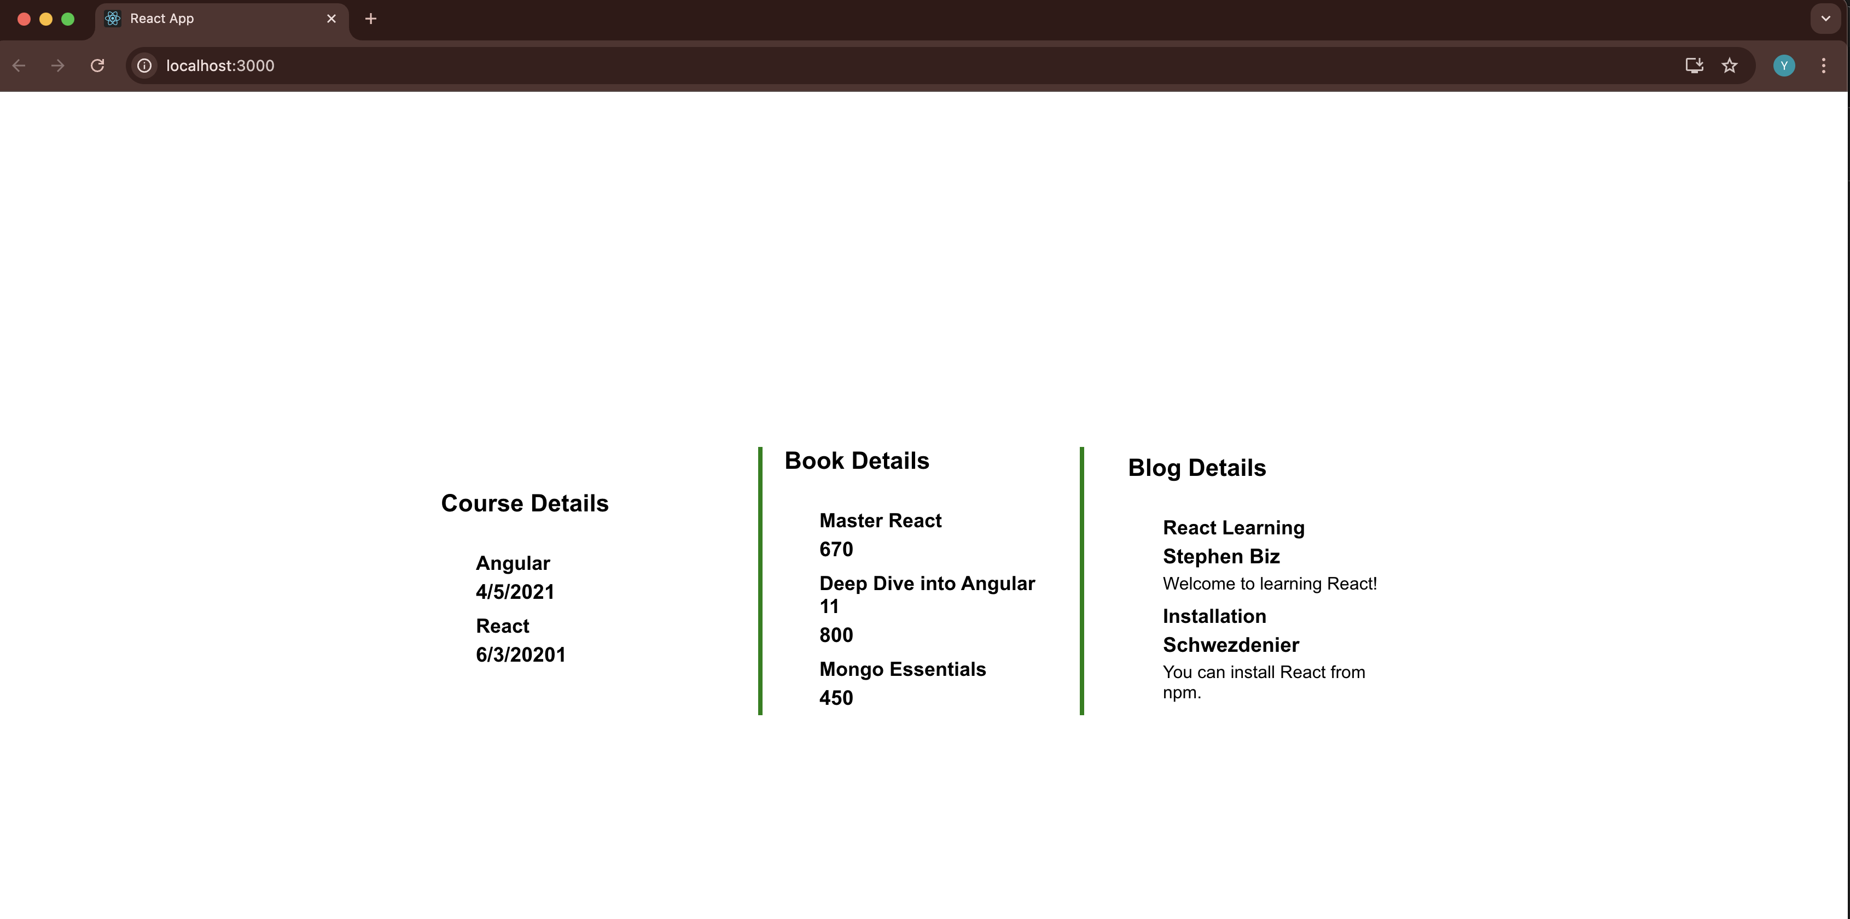

(b) Additional important hands-on
Filename : 14. ReactJS-HOL
Step 1:
Unzip the file on the 14.ReactJS-HOL word file.And install npm in that unzipped folder.

Step 2:
Redirect to the react folder named employeesapp.Create ThemeContext.js and Change the App.js,Employee.js,EmployeesList.js,EmployeeCard.js, and EmployeeCard.module.css code in the src/ directory.

ThemeContext.js:
import React from 'react';
const ThemeContext = React.createContext('light');
export default ThemeContext;

Employee.js:
class Employee {
constructor(id, name, email, phone) {
this.id = id;
this.name = name;
this.email = email;
this.phone = phone;
}
}

const EmployeesData = [
new Employee(101, 'Jojo', 'jojo@congizant.com', '98238971234'),
new Employee(102, 'Sam', 'sam@congizant.com', '9981184126'),
new Employee(103, 'Elisa', 'elisa@cognizant.com', '9989389735')
];

export default Employee;
export { EmployeesData };

EmployeesList.js:
import EmployeeCard from './EmployeeCard';
function EmployeesList(props) {
return (
<div>
<h1>Employees List</h1>
{
props.employees.map(employee =>
<EmployeeCard employee={employee} key={employee.id} />
)
}
</div>
);
}

export default EmployeesList;

EmployeeCard.js:
import Styles from './EmployeeCard.module.css';
import { useContext } from 'react';
import ThemeContext from './ThemeContext';

function EmployeeCard(props) {
const theme = useContext(ThemeContext); // 'light' or 'dark'
const buttonClass = theme === 'light' ? Styles.light : Styles.dark;

return (
<div className={Styles.Card}>
<h3>{props.employee.name}</h3>
<p>{props.employee.email}</p>
<p>{props.employee.phone}</p>
<p>
<a href="#" className={buttonClass}>Edit</a>
<a href="#" className={buttonClass}>Delete</a>
</p>
</div>
);
}

export default EmployeeCard;

EmployeeCard.module.css:
.Card {
border: 1px solid #ccc;
padding: 1rem;
margin-bottom: 1rem;
border-radius: 5px;
}
.light {
background-color: white;
color: black;
padding: 0.4rem 0.8rem;
border: 1px solid black;
text-decoration: none;
margin-right: 10px;
display: inline-block;
}
.dark {
background-color: black;
color: white;
padding: 0.4rem 0.8rem;
border: 1px solid white;
text-decoration: none;
margin-right: 10px;
display: inline-block;
}

Step 3:
Run the command npm start on your vs code terminal.
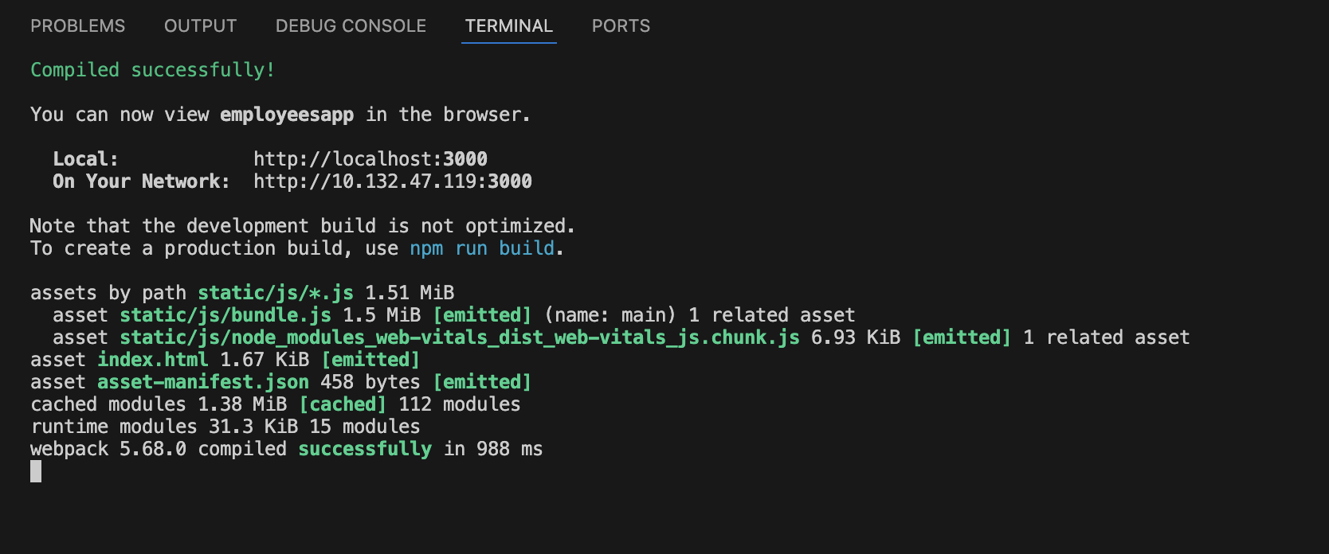
It opens the browser.
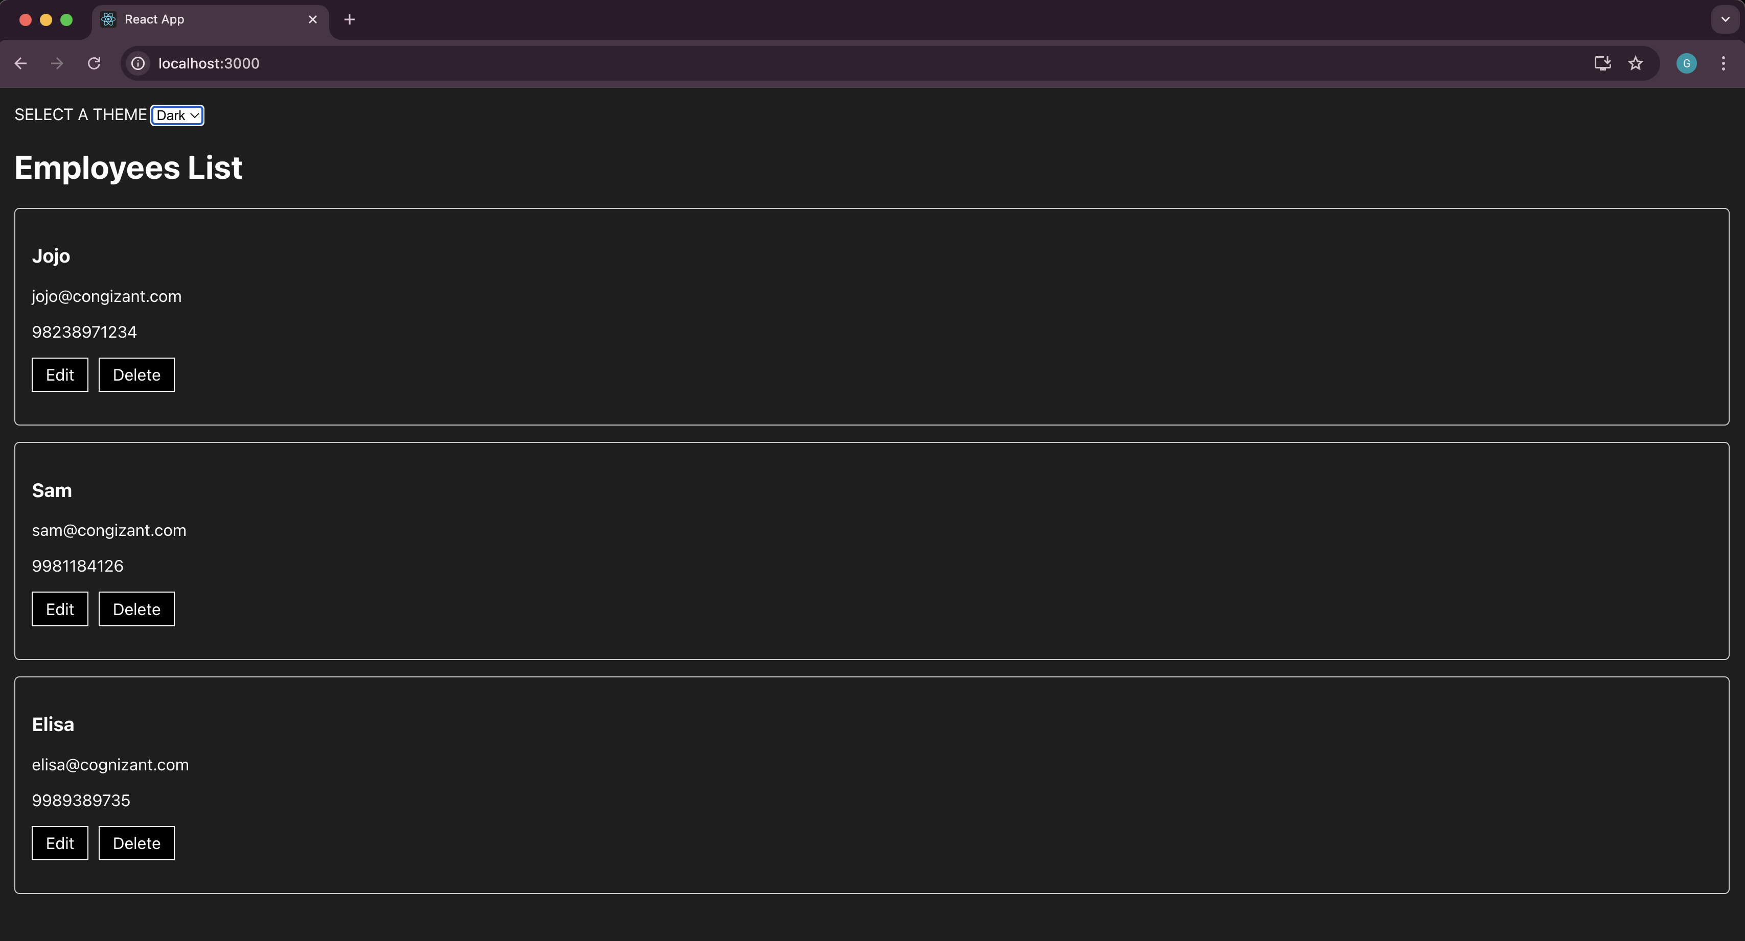

Filename : 15. ReactJS-HOL
Step 1:
Install node.js from official website and setup on the system.And Create a new folder named react15 for this project and open on vs code.

Step 2:
Run the command npx create-react-app ticketraisingapp on the vs code terminal.And redirect to the react folder named ticketraisingapp.Change the App.js and Create ComplaintRegister.js in the src/ directory.

App.js:
import React from 'react';
import ComplaintRegister from './ComplaintRegister';
function App() {
return (
<div className="App">
<ComplaintRegister />
</div>
);
}
export default App;

ComplaintRegister.js:
import React, { Component } from 'react';
class ComplaintRegister extends Component {
constructor(props) {
super(props);
this.state = {
ename: '',
complaint: '',
NumberHolder: Math.floor(Math.random() * 100) + 1
};

this.handleChange = this.handleChange.bind(this);
this.handleSubmit = this.handleSubmit.bind(this);
}

handleChange(event) {
this.setState({ [event.target.name]: event.target.value });
}

handleSubmit(event) {
var msg = 'Thanks ' + this.state.ename +
'\nYour Complaint was Submitted.\nTransaction ID is: ' + this.state.NumberHolder;
alert(msg);
event.preventDefault();
}

render() {
return (
<div style={{
display: 'flex',
justifyContent: 'center',
alignItems: 'center',
flexDirection: 'column',
minHeight: '100vh'
}}>
<h1 style={{ color: 'red', fontWeight: 'bold', marginBottom: '30px' }}>
Register your complaints here!!!
</h1>

<form onSubmit={this.handleSubmit} style={{
display: 'flex',
flexDirection: 'column',
alignItems: 'flex-start',
gap: '20px'
}}>
<div style={{ display: 'flex', alignItems: 'center', gap: '15px' }}>
<label style={{ width: '80px' }}>Name:</label>
<input
type="text"
name="ename"
value={this.state.ename}
onChange={this.handleChange}
required
/>
</div>

<div style={{ display: 'flex', alignItems: 'center', gap: '15px' }}>
<label style={{ width: '80px' }}>Complaint:</label>
<textarea
name="complaint"
value={this.state.complaint}
onChange={this.handleChange}
required
/>
</div>

<div style={{ alignSelf: 'center' }}>
<button type="submit">Submit</button>
</div>
</form>
</div>
);
}
}

export default ComplaintRegister;

Step 3:
Run the command npm start on your vs code terminal.
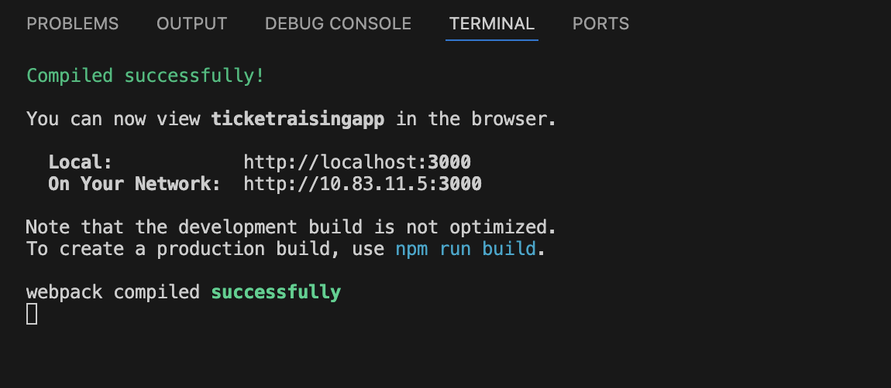

It opens the browser.
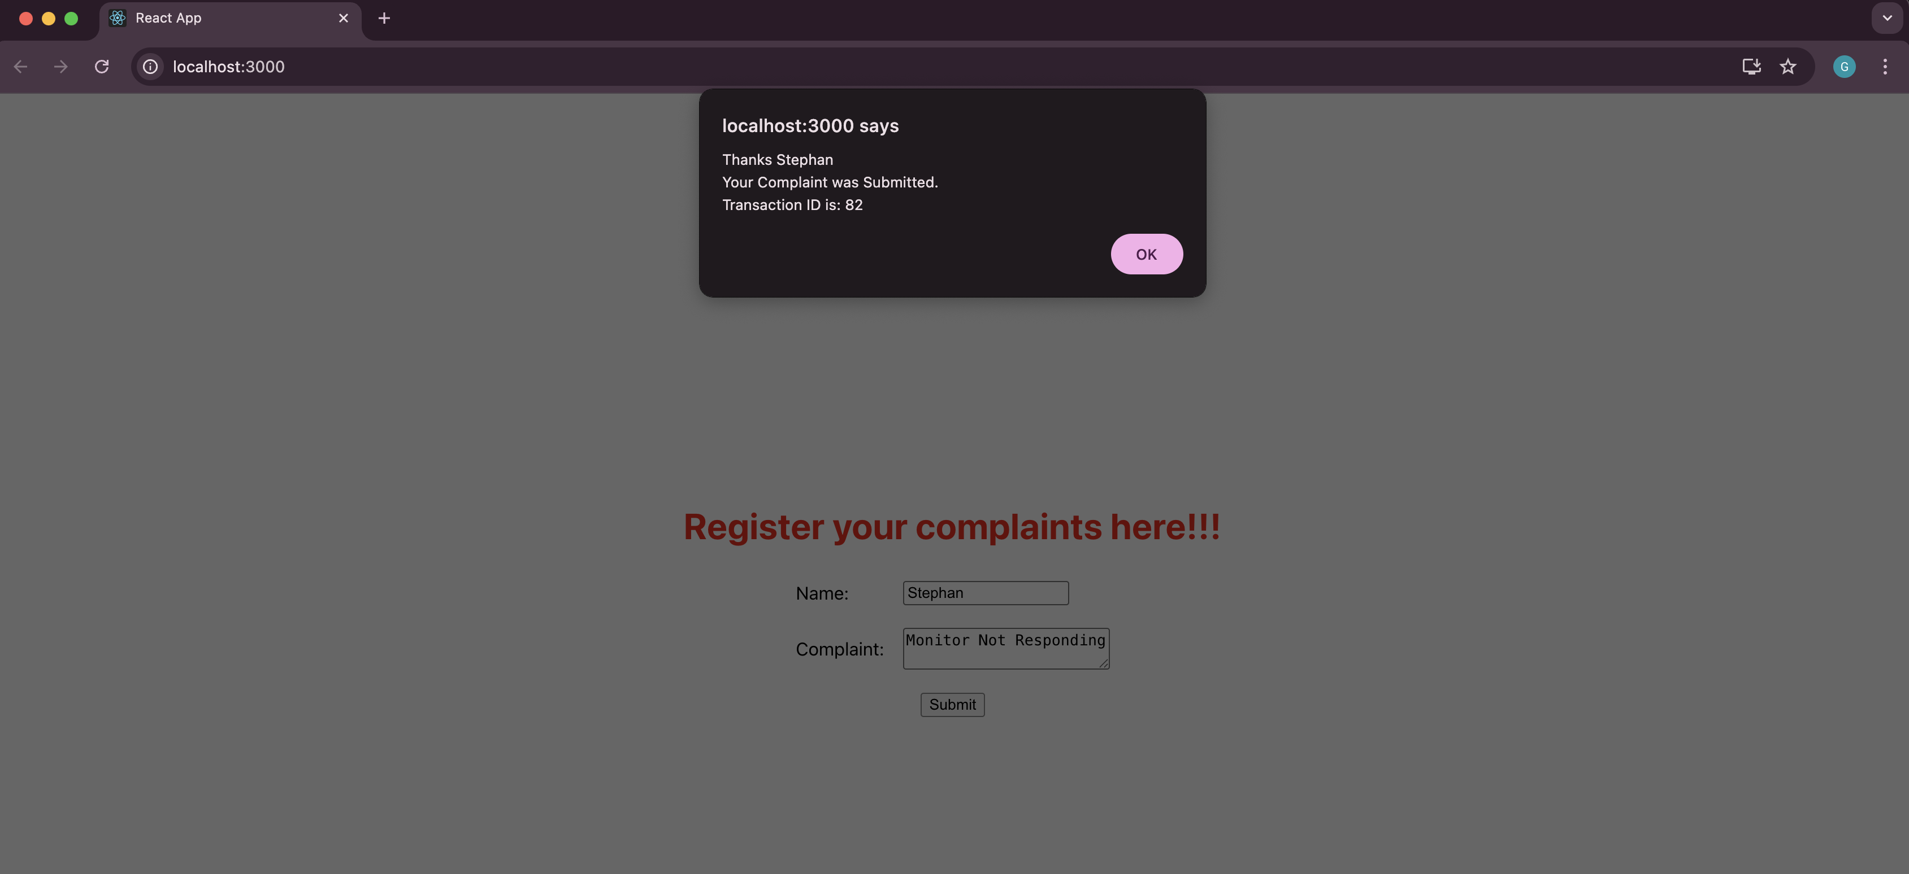

Filename : 16. ReactJS-HOL
Step 1:
Install node.js from official website and setup on the system.And Create a new folder named react16 for this project and open on vs code.

Step 2:
Run the command npx create-react-app mailregisterapp on the vs code terminal.And redirect to the react folder named mailregisterapp.Change the App.js and Create register.js and register.css in the src/ directory.

register.js:
import React from 'react';
import './register.css';

class Register extends React.Component {
constructor(props) {
super(props);
this.state = {
fullName: '',
email: '',
password: '',
errors: {
fullName: '',
email: '',
password: ''
}
};
}

handleChange = (event) => {
const { name, value } = event.target;
let errors = this.state.errors;

switch (name) {
case 'fullName':
errors.fullName = value.length < 5 ? 'Full Name must be 5 characters long!' : '';
break;
case 'email':
const validEmailRegex = RegExp(
/^(([^<>()[\]\\.,;:\s@"]+(\.[^<>()[\]\\.,;:\s@"]+)*)|(".+"))@(([^<>()[\]\\.,;:\s@"]+\.)+[^<>()[\]\\.,;:\s@"]{2,})$/i
);
errors.email = validEmailRegex.test(value) ? '' : 'Email is not valid!';
break;
case 'password':
errors.password = value.length < 8 ? 'Password must be 8 characters long!' : '';
break;
default:
break;
}

this.setState({ errors, [name]: value });
};

validateForm = (errors) => {
let valid = true;
Object.values(errors).forEach((val) => val.length > 0 && (valid = false));
return valid;
};

handleSubmit = (event) => {
event.preventDefault();
if (this.validateForm(this.state.errors)) {
alert('Valid Form');
} else {
if (this.state.errors.fullName !== '') {
alert(this.state.errors.fullName);
}
if (this.state.errors.email !== '') {
alert(this.state.errors.email);
}
if (this.state.errors.password !== '') {
alert(this.state.errors.password);
}
}
};

render() {
return (
<div className="register-container">
<h2 className="register-title">Register Here!!!</h2>
<form onSubmit={this.handleSubmit} className="register-form">
<div className="form-group">
<label>Name:</label>
<input
type="text"
name="fullName"
onChange={this.handleChange}
noValidate
/>
</div>
<div className="form-group">
<label>Email:</label>
<input
type="email"
name="email"
onChange={this.handleChange}
noValidate
/>
</div>
<div className="form-group">
<label>Password:</label>
<input
type="password"
name="password"
onChange={this.handleChange}
noValidate
/>
</div>
<div className="form-group">
<button type="submit">Submit</button>
</div>
</form>
</div>
);
}
}

export default Register;

register.css:
.register-container {
display: flex;
flex-direction: column;
align-items: center;
margin-top: 100px;
}

.register-title {
color: red;
text-align: center;
font-weight: bold;
font-size: 28px;
margin-bottom: 30px;
}

.register-form {
display: flex;
flex-direction: column;
align-items: center;
}

.form-group {
display: flex;
align-items: center;
margin: 10px 0;
}

.form-group label {
width: 100px;
text-align: right;
margin-right: 10px;
font-size: 16px;
}

.form-group input {
padding: 5px 10px;
font-size: 16px;
width: 200px;
}

App.js:
import React from 'react';
import Register from './register';
function App() {
return (
<div className="App">
<Register />
</div>
);
}

export default App;
Step 3:
Run the command npm start on your vs code terminal.
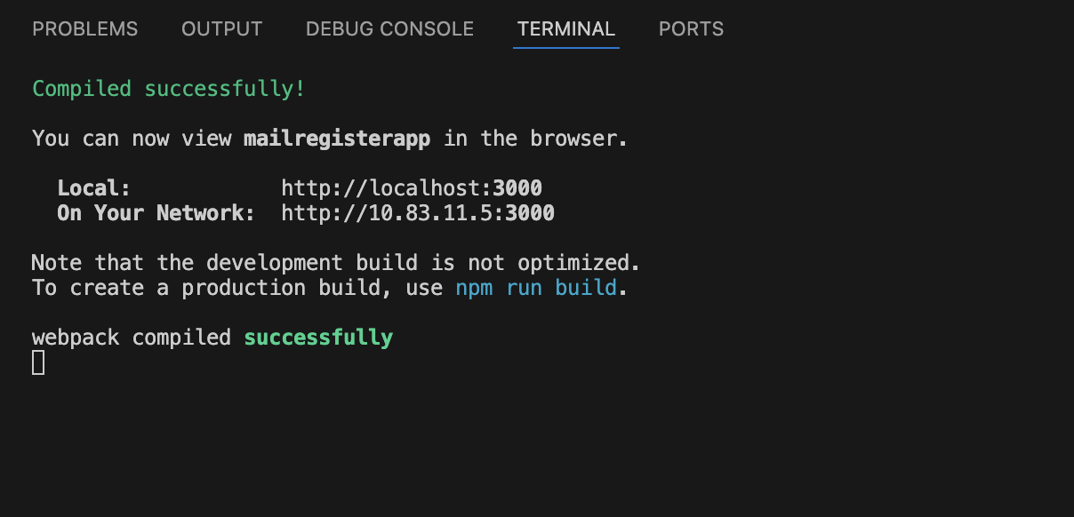

It opens the browser.
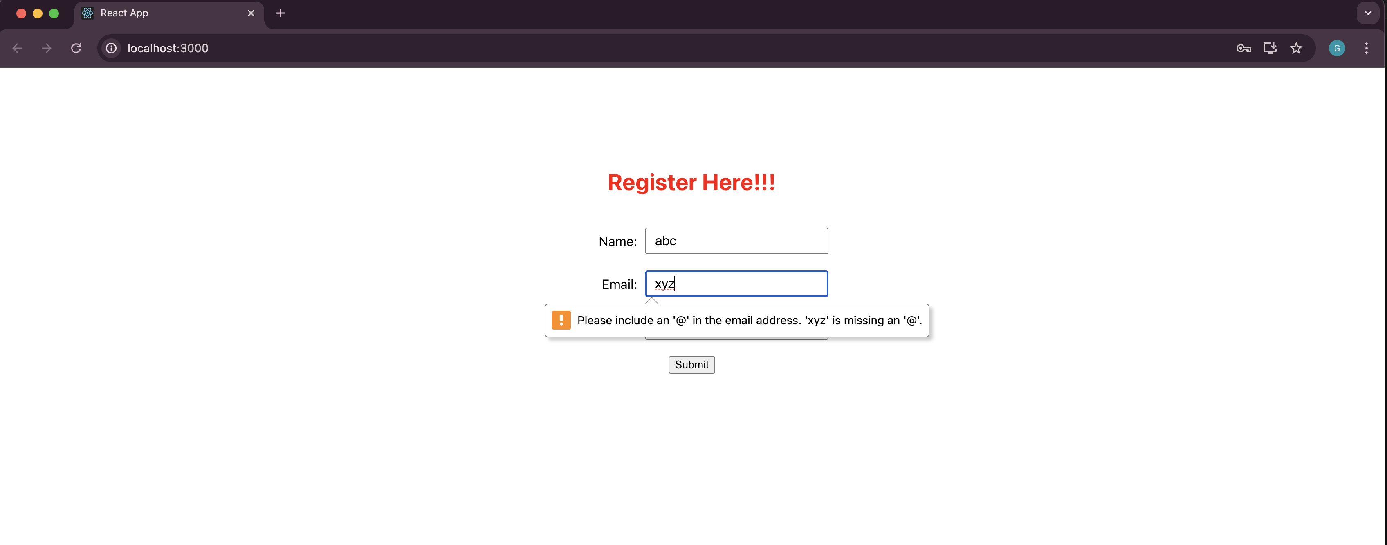

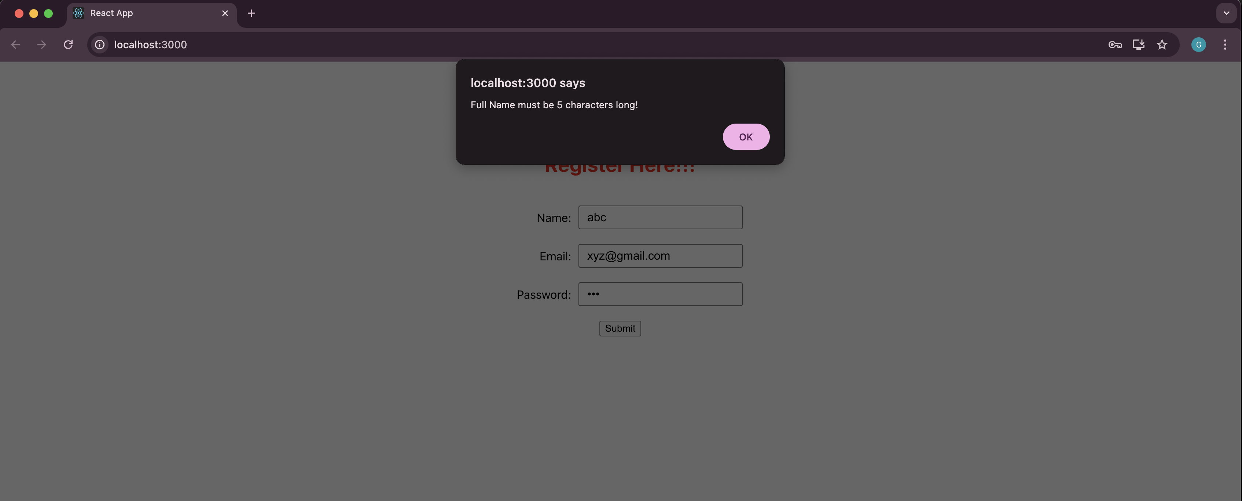

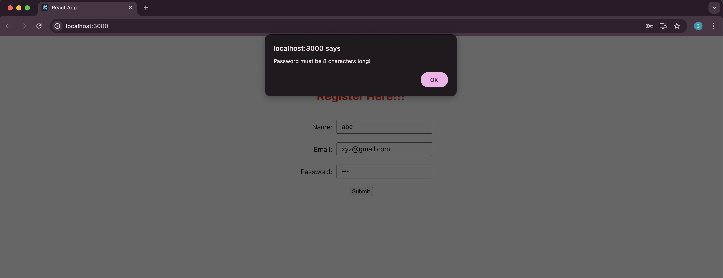

Filename : 17. ReactJS-HOL
Step 1:
Install node.js from official website and setup on the system.And Create a new folder named react17 for this project and open on vs code.

Step 2:
Run the command npx create-react-app fetchuserapp on the vs code terminal.And redirect to the react folder named fetchuserapp.Change the App.js,index.js and index.css and create Getuser.js in the src/ directory.

Getuser.js:
import React, { Component } from 'react';
class Getuser extends Component {
constructor(props) {
super(props);
this.state = {
person: null,
loading: true,
error: null
};
}

componentDidMount() {
console.log("Using static data for Mr Donato Nunes");

const mockData = {
name: {
title: "Mr",
first: "Donato",
last: "Nunes"
},
picture: {
large: "https://i.pravatar.cc/300?img=12"
}
};

setTimeout(() => {
this.setState({ person: mockData, loading: false });
}, 1000);
}
render() {
const { person, loading, error } = this.state;

if (loading) {
return <div style={{ textAlign: 'center', marginTop: '50px' }}>Loading...</div>;
}

if (error) {
return <div style={{ textAlign: 'center', marginTop: '50px', color: 'red' }}>Error: {error}</div>;
}

return (
<div style={{ textAlign: 'center', marginTop: '50px' }}>
<h1>{person.name.title} {person.name.first} {person.name.last}</h1>
<img
src={person.picture.large}
alt="User"
style={{
borderRadius: '50%',
width: '150px',
height: '150px',
border: '3px solid #ccc',
objectFit: 'cover'
}}
/>
</div>
);
}
}
export default Getuser;

App.js:
import React from 'react';
import Getuser from './Getuser';
function App() {
return (
<div className="App">
<Getuser />
</div>
);
}

export default App;

index.js:
import React from 'react';
import ReactDOM from 'react-dom/client';
import './index.css';
import App from './App';
const root = ReactDOM.createRoot(document.getElementById('root'));
root.render(
<React.StrictMode>
<App />
</React.StrictMode>
);

index.css:
body {
font-family: Arial, sans-serif;
margin: 0;
padding: 0;
background-color: #f9f9f9;
}

Step 3:
Run the command npm start on your vs code terminal.
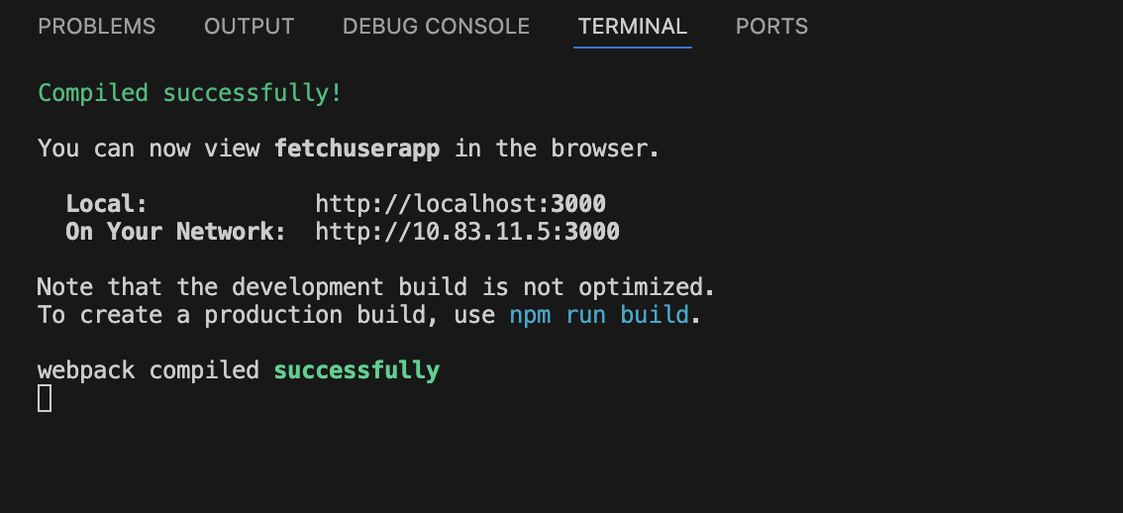
It opens the browser.
